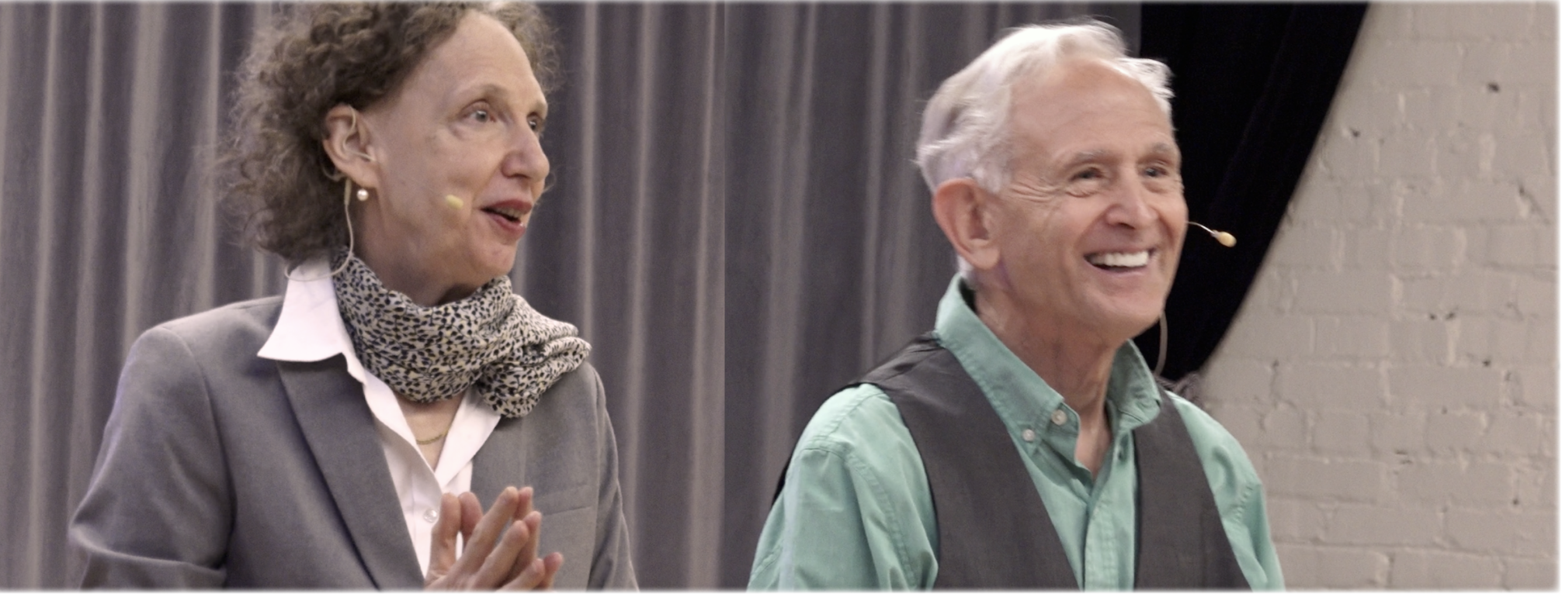

Peter A Levine, PhD & Betsy Polatin, MFA, SEP present

Trauma in the Public Eye
Saturday, March 13th - Sunday, March 14th, 2021
2-DAYS ONLINE 10:30 AM - 4:30 PM PST (1:00 PM - 2:00 PM PST Lunch)
This unique masterful workshop will be packed with demonstrations, lectures, and group exercises.
Trauma in the Public Eye invites all performers, practitioners, teachers, and anybody else who is interested in trauma, movement, breathing, and human behavior. After all, aren’t we all performers? Just signing into a Zoom room full of people for an online gathering can be triggering. That wave of fear that washes over, bringing up hints of doubt, shame, or unworthiness. Paying attention to bodily cues and nervous system signals can help shift these states and bring us to a more authentic sense of self-awareness and inner-confidence.
During this 2-day Online Workshop, you will explore your inner sensations, motivations, and intentions, as you prepare, execute, and complete a performance or a simple interaction (such as introducing yourself) in front of others on Zoom. You will learn how to safely and actively utilize your unique emotional trauma history along with an enhanced body awareness and easier breathing to convey a wider spectrum of feelings and inner sensations. Trauma, when accessed at the level of body sensations can open us up to an incredible yet subtle array of feelings fostering a deeper connection to ourselves and others.
Workshop Faculty
Internationally Renowned Trauma Expert and Developer of Somatic Experiencing®
Peter A Levine, PhD
Movement and Breathing Specialist and Creator of Humanual®
Betsy Polatin, MFA, SEP
EARLY BIRD PRICING NOW: $400 - REGULAR PRICE WILL BE: $425
to register

